

FACULTY OF TECHNOLOGY AND ENGINEERING
DEVANG PATEL INSTITUTE OF ADVANCE TECHNOLOGY AND RESEARCH
DEPARTMENT OF INFORMATION TECHNOLOGY

A.Y. 2026-27 [ODD]

LAB MANUAL

CSUC201: DSA


Practical 3: Sorting Algorithms: Comparison-Based,
Counting-Based and Digit-Based Strategies.

Problem 1
A teacher has a stack of student answer sheets with marks written on them and needs to arrange them in order before entering grades. She tries three different methods: in the first, she repeatedly compares adjacent sheets and swaps them if they are out of order; in the second, she finds the lowest-marked sheet each time and places it at the front; in the third, she picks each sheet one by one and inserts it into its correct position among the already-arranged sheets. Implement all three methods and for each one, print the sorted order of marks.
Output :
Bubble :
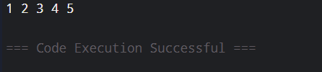
Insertion :
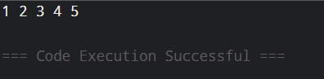
Selection :
Errors Faced :-
-In this problem, I was confused about managing the conditions of Insertion Sorting & Selection Sorting but I overcame it by tracing algorithm step by step.

Problem 2
A paint shop has buckets labelled with one of three colour codes — 0, 1, or 2 — but they are stored in a random order. The shop owner wants all 0s together, then all 1s, then all 2s, without using any extra storage. Given the list of colour codes, rearrange them in place and print the result.
Output :
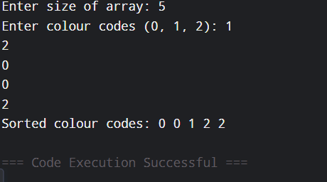

Errors Faced :-
-I found difficult to understand the problem, but then I understand the problem and made an algorithm to solve it.
Github Repo link :
https://github.com/vaidik5646/FDSA-BATCH-A/tree/main/practical3
Key question :
- [Problem 1] One of the three methods can detect early that the list is already sorted and stop without doing any more work. Which method is it, how would you add that detection, and why can the other two not do the same?
-->The Bubble Sort method can detect that the list is already sorted. We can use a swapped variable and set it to true whenever a swap happens; if no swap happens in one complete pass, the algorithm stops. The other two methods cannot easily stop early because they still need to complete their normal comparisons to guarantee the list is sorted.
- [Problem 2] If your solution makes two passes through the list, can you identify which decision in your logic forces the second pass? Is there a way to restructure that decision to eliminate it?
-->The second pass is usually caused by making a separate loop to check or process the elements again after the first pass. We can eliminate it by combining the required decision or processing into the same loop, so each element is handled during the first pass itself. This reduces unnecessary work and can improve the efficiency of the solution.

